Assignment Week-4
- Screenshot of Resource Group
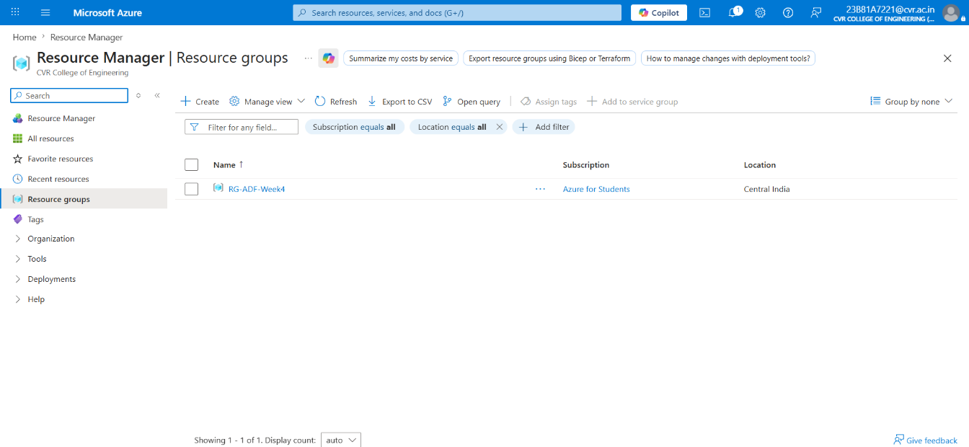

- Screenshot of container with uploaded file
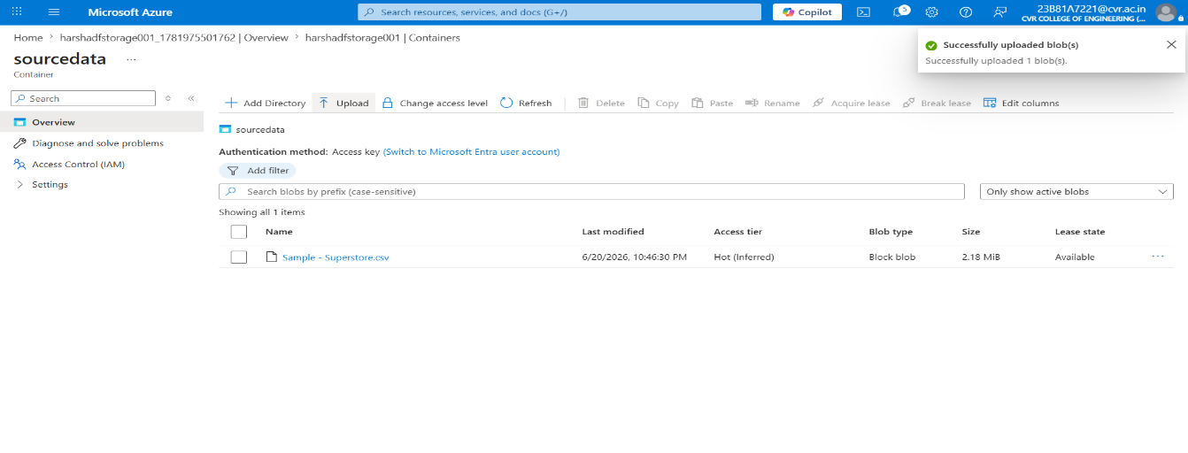
- Screenshot of Linked Service
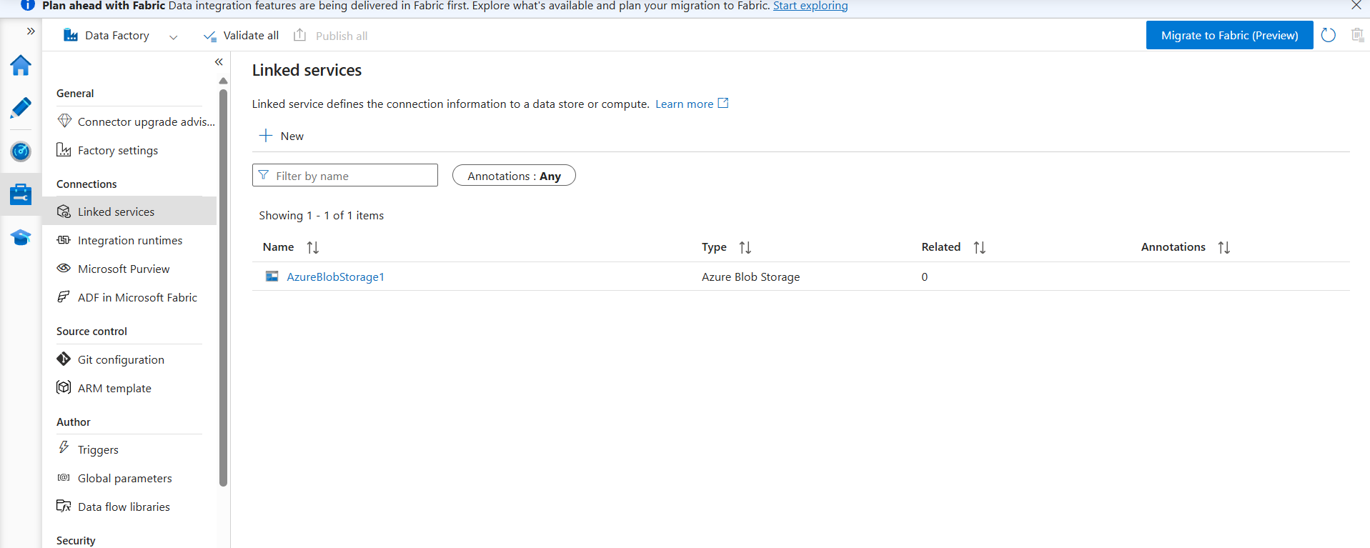
- Screenshot of dataset
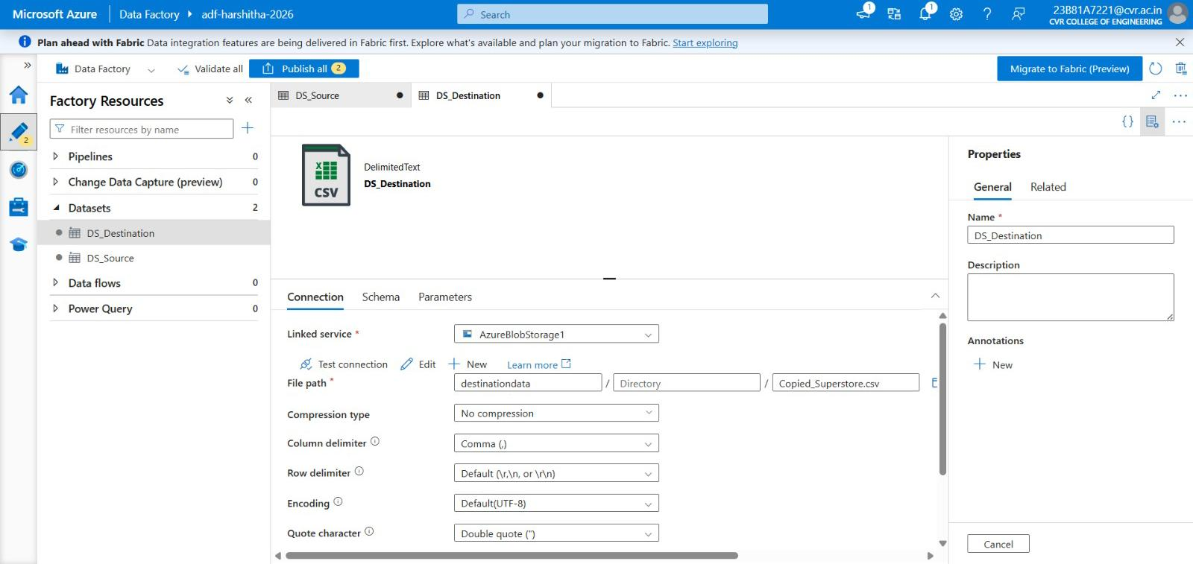
- Screenshot of Get Metadata activity
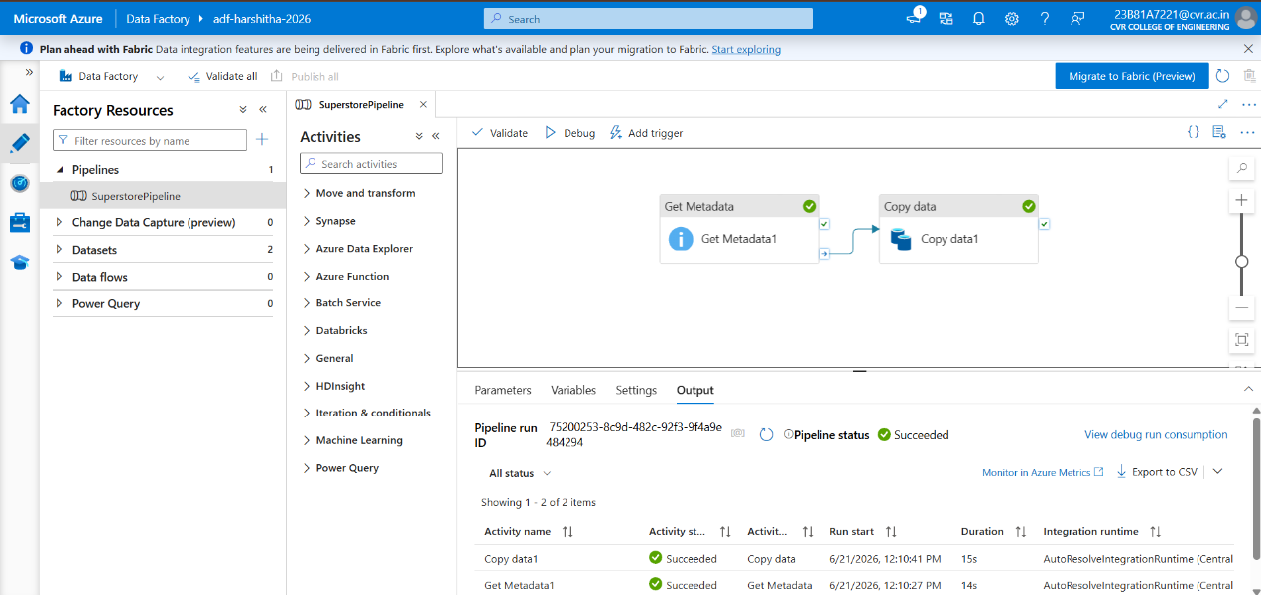
- Screenshot of pipeline design
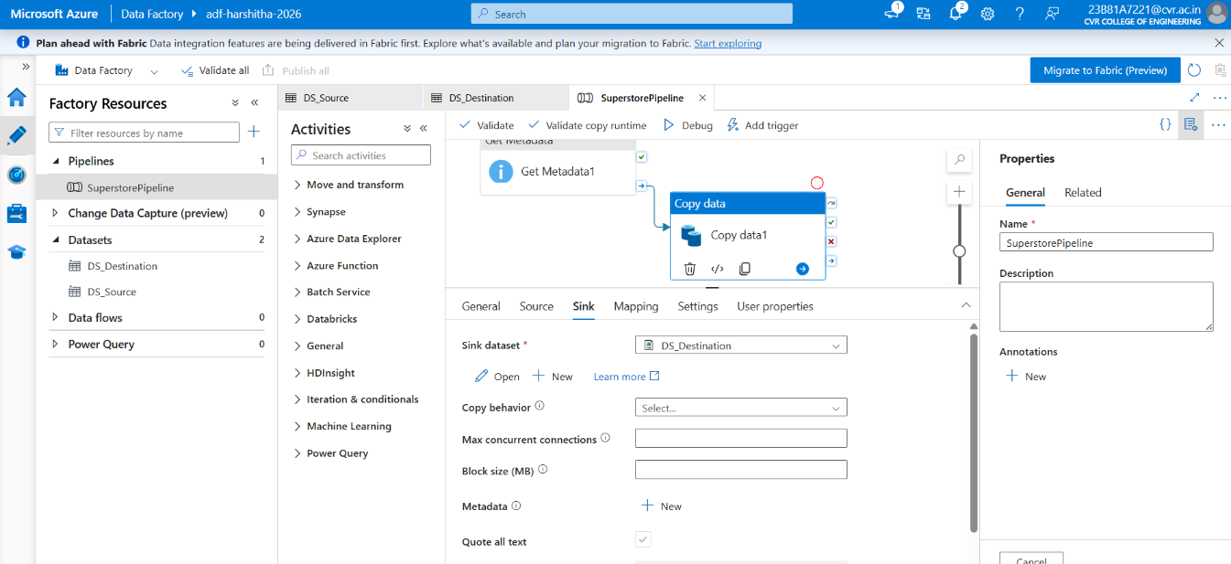
- Screenshot showing pipeline execution (Succeeded)
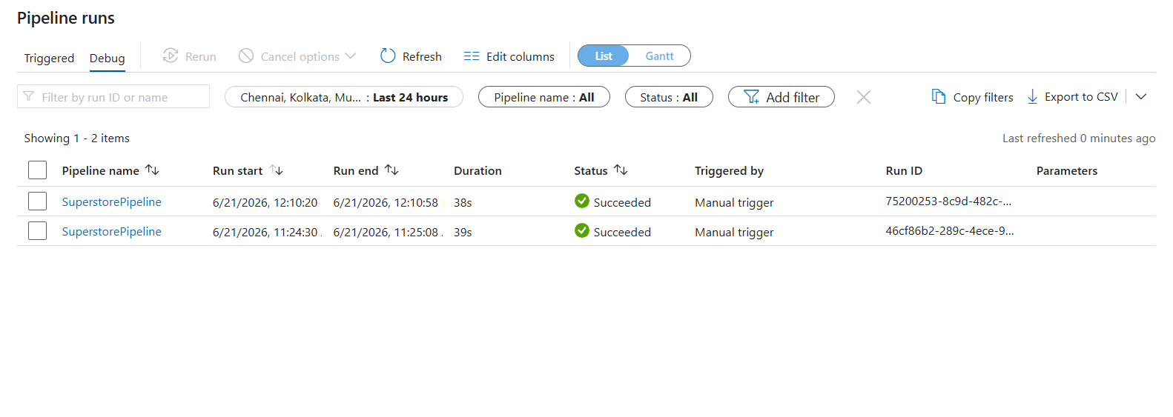
- Screenshot of role assignment
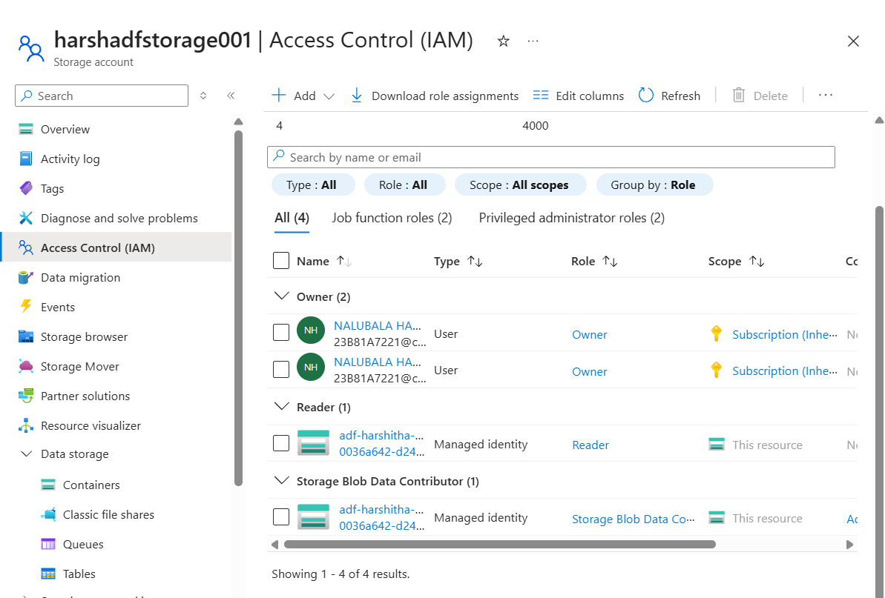
- Output File in destinationdata container
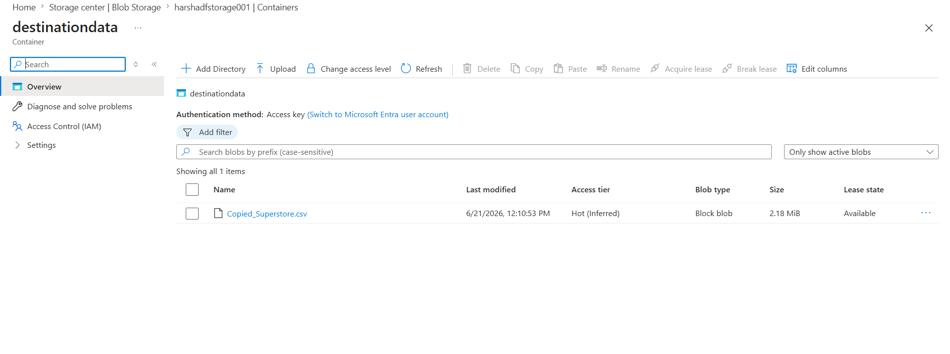
Brief Summary
- Created a Resource Group (RG-ADF-Week4) in Microsoft Azure.
- Created an Azure Storage Account and configured Blob Storage containers.
- Uploaded the Sample-Superstore.csv file into the sourcedata container.
- Created an Azure Data Factory (adf-harshitha-2026).
- Configured a Linked Service to connect Azure Data Factory with Azure Blob Storage.
- Created source dataset (DS_Source) and destination dataset (DS_Destination).
- Designed a pipeline containing Get Metadata and Copy Data activities.
- Used Get Metadata activity to validate the source file before processing.
- Configured the Copy Data activity to copy data from the source container to the destination container.
- Assigned the required IAM roles (Reader and Storage Blob Data Contributor) to enable ADF access to Storage Account.
- Executed the pipeline successfully using Debug/Trigger.
- Verified successful execution in the Monitor section.
- Confirmed that the output file (Copied_Superstore.csv) was created in the destinationdata container.
- Successfully implemented an end-to-end Azure Data Factory pipeline for data movement and metadata validation.

